April Monthly Report

I did not document the followers on the last day of March. Therefore, the change of the number of followers is from 2021/3/4 to 2021/5/6.

On 2021/3/4, there were 31805 followers.

On 2021/5/6, there are 44027 follwers.

Since it is almost a year for me to take the weibo blogger position, I created a graph to show the followers change:

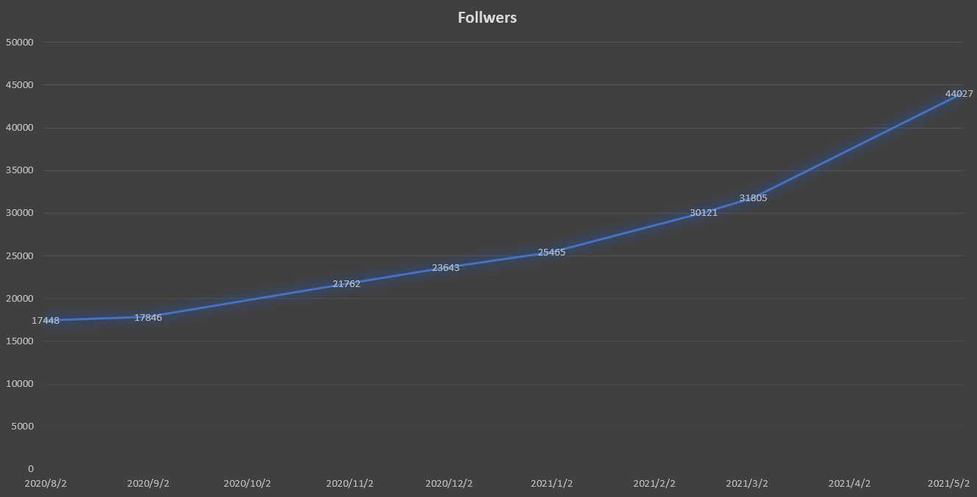

I believe it is because of the covid-19. More Chinese potential applicants seek information from the Internet. And Weibo is still the most popular social media in China.

Attention: This followers change part is the same as the March Monthly Report.

In this month, I published a series of count down of KTH admission. The shining point is that I use the similar sound to relate with KTH or Sweden interesting things. For example, for Number 10 I introduced the ten-digit personal number. For number 9, in Chinese it sounds the same as wine. Therefore I introduced how to buy alcohol in Sweden. For number 8, I introduced the interesting August at KTH. For number 7, I introduced the courses selection at KTH since most courses are 7.5 credits.

Besides this series, I also attended the QQ group answering questions for two afternoons in April. Since it is the most important thing for Chinese social media group, I also published several posts about this. This basically is the first half of April. In the latter part, I included some videos which are really helpful for student study and horizon broadening. In the end of this month, I introduced something about Sweden anthem and agriculture.

Overall, I published 31 posts. 24 of them are original. I went through a high-product month happily!